Research On The Application Effect Of Cognitive Stimulation Therapy In Patients With Alzheimer's Disease Based On Expert Consultation And Semi-Structured Interviews
Li Shuzhen^{1，2}， Ge Hongyan²，Wu Wei²， Wang Ruiying³，Zamzaliza Abdul Mulud⁴
¹Centre for Nursing Studies, Faculty of Health Sciences, Universiti Teknologi MARA, 42300 Puncak Alam, Selangor, Malaysia；
²Heze Jia Zheng Vocational College，Heze 274300，China.
³Shanxian Central Hospital is a hospital，Heze 274300，China
⁴ Centre for Nursing Studies, Faculty of Health Sciences, Universiti Teknologi MARA, 42300 Puncak Alam, Selangor, Malaysia.
Coresponding author email: zamzaliza@uitm.edu.my

Abstract
Background: The awareness and utilization of psychological therapies for Alzheimer's disease have increased significantly in recent years. Limitations on the utilization of pharmacological therapy for Alzheimer's disease in China have corresponded with this surge in greater studies in the field. For individuals who have Alzheimer's disease, cognitive stimulation therapy (CST) is quick self-help that is founded on the theories of quality and cognitive functioning. Alzheimer's disease people often participate in cognitive behavioral programs; however, their expense has never been studied.
Aim: Being part of a meta‐analysis, we analyze the application effectiveness of a cognitive stimulation therapy (CST) program that is based on recent research for Alzheimer's disease patients.
Methodology: A CST group therapy was given to 91 Alzheimer's patients who resided in healthcare settings or the general public multiple times per week for eight weeks; the other 70 people with Alzheimer's disease got medical therapy. Costs were computed and resource utilization was tracked for 8 weeks both before and after the therapy. It was determined by a value study. In a value study, cognition, and quality of life were the major and tertiary outcomes, respectively. Contours of cost-effectiveness and acceptance were drawn. It is driven based on expert consultation and semi-structured interviews.
Result: In Alzheimer's disease, cognitive stimulation therapy improves intelligence and standard of living, and there was no difference in implementation expenditures between the categories. Regarding both outcome metrics, there is a significant chance that CST seems to be more expensive than conventional therapy within realistic expectations.
Conclusion: The efficacy of cognitive stimulation therapy for Alzheimer's patients is superior to conventional treatment, and it could be the greater value. The outcomes contrast well with pharmacological studies for Alzheimer's. Many people with Alzheimer's disease may benefit significantly from CST groups.
Keywords: Cognitive stimulation therapy (CST), Alzheimer's disease, intelligence, the standard of living, implementation expenditures.
I. INTRODUCTION
Caregiver partners or other relatives frequently look after Alzheimer's patients who reside in the household. According to estimates, women worldwide concern 51–91% of Alzheimer's patients, often as wives or children. Alzheimer's is a degenerative illness that affects around 50 million people worldwide (Saragih et al. (1)). Patients continuously undergo intellectual and functional loss. As individuals age, Alzheimer's disorders become more common; control points 75 are those most at risk. Disorder, issues with communicating and recognizing people and locations, and a diminished capacity to carry out everyday tasks are among the vast variety of signs (Lauritzen et al. (2)). There are several types of approaches to Alzheimer's disease: proactive medical treatment, search for disorder medications and improved care and assistance. According to recent research, early or middle learning and health-related behaviors improvements, as well as simulation and model-based behavioral therapies for somewhat elderly adults at recognized dementia risk, may protect roughly 40% of Alzheimer's disease (Mody and Bhoosreddy (3)). Such precautionary measures must be taken, but the results won't show up right away. There haven't been many advances in the hunt for treatments that may change illness; in any event, the costs of brand-new drugs and their related indicators may be formidable barriers to their broad use. Consequently, providing the greatest treatment to every Alzheimer's patient and their caregivers should be a top priority (Knapp et al. (4)).
However, several caregivers often enjoy rewarding caregiving in their daily lives, experiencing enrichment and satisfaction when they provide care. Despite the continual cognitive deterioration, many individuals who are living with an individual who has Alzheimer's disease cherish companies that require familiarity in regular living that expresses respect and understanding and a feeling of closeness (Ali et al. (5)). Alzheimer's disease (ID), which concerns 1% of the community, is characterized by the poor cognitive and adaptable performance that first appears well before age of 18. The frequency of Alzheimer's is 7.5 times greater in people. It is expected to rise as an individual age (Garg and Harita (6)). People with Down syndrome over the age of 40 are most at risk of being diagnosed, with one continuous research showing that all 97% would eventually acquire Alzheimer's disease in more than 25 years span. The primary cause of death in persons having Down syndrome is indeed Alzheimer's. The increase in risk and rapidly progressive Alzheimer's seen in patients with less intellectual capacity brought on by or before the concussion (Gonzalez et al. (7). Due to these limitations, we analyze the application effect of cognitive stimulation therapy in patients with Alzheimer's disease based on expert consultation and semi-structured interviews.
The remainder of this study is structured as follows. Section II presents the related works and issues recommendations. In Section III, the impact of cognitive stimulation therapy on expert consultation and semi-structured interviews with Alzheimer's patients is examined. Section IV includes the findings and analyses. Section V highlights the conclusion.
II. ASSOCIATED LITERATURE
Patients having Alzheimer's were given a 15-week multi-component organization rehabilitation in Denmark (N = 44). A systematic procedure was used to examine the appropriateness of the treatment, such as whether individuals with Alzheimer's disease and their families considered the treatment valuable, as well as to observe and evaluate changes in respondents' physiological and cognitive functional ability. This approach included an interview process, findings, test results of cognitive and physical working, and an interviewer-assisted survey on life satisfaction. The research was done from June 2018 to August 2019 (Skov et al. (8)).
Andrade et al. (9) investigated the impact of failover cluster excitatory transcranial direct current stimulation (tDCS) coupled with cognitive stimulation (CS) for two months on cognition and brainwaves in individuals having Alzheimer's disease, as well as the correlation underlying them. Alzheimer's incidence has also been rising, especially in developing nations, yet treatment options are nevertheless few (Ahmed and Aatiqa (10)). Psychological-behavioral challenges, in addition to the standard of living for those with advanced dementia, may all be improved using cognitive therapies, which are widely acknowledged as effective strategies. They were randomly assigned with either 13 sessions of CST with normal treatment (TAU; n = 23) or TAU (n = 24) over seven weeks in a single survey. Measurements were made of modifications in the cognitive, standard of living, negative affect, caretaker load, and functioning (Marinho et al. (11)).
Rai et al. (12) examined the portability of an individual cognitive stimulation therapy (iCST) application strategy and the practicality of carrying out a large-scale randomized controlled trial to contrast the therapeutic potential of the iCST application strategy with that of normal treatment for individuals with Alzheimer's disease (Shahabaz and Afzal (13)). One of the most common substantial proof therapies for Alzheimer's disease patients is interventions for improving treatment. They also evaluate the efficacy of an Italian adaption of the CST paradigm in the immediate and long-term after the completion of therapy and three months later (Carbone et al. (14)).
112 elderly individuals with Alzheimer's disease were included in a separate, multi-center, prospective randomized experiment. The primary efficacy metric was cognitive, with satisfaction with life, interaction, independence, anxiousness, depressive symptoms, and overall well-being serving as supplementary indicators (Li (15)). They also looked if the advantages of CST vary by setting, age, and degree of executive functioning. Alvares et al. (16) created criteria for culturally modifying CST by the constructive approach to modifying treatment. They converted the English CST booklet into German using this neighborhood methodology, which included two modification phases, multi-professional group discussions, and two training CST classes (n=13) in circumstances that were typical of the German medical system. Pre-post comparisons of common measures on cognition, sadness, satisfaction with life, and consciousness were used to analyze the effectiveness in both groups (Salihu and ZayyanuIyya (17)). Having impact values within the same level as in prior randomized controlled trials, they were capable of reproducing earlier results of better cognition as evaluated. In addition, consciousness improved after CST compared to before, suggesting that CST may activate intellect via a favorable, self-rewarding process (Werheid et al. (18)).
III. DESIGN METHODOLOGY
For those with moderate to advanced Alzheimer's disease, Cognitive Stimulation Therapy (CST) is a quick, research intervention. The 14 or more sessions of thematic activities that constitute group CST therapy often occur in 2 weeks. Sessions are designed to participate fully and excite those who have Alzheimer's disease while also offering a superior learning atmosphere and the privileges of grouping. The benefits of CST seem to be around the same magnitude as those associated with the pharmaceutical Alzheimer therapies that are now on the market based on expert consultation and semi-structured interviews. Figure 1 indicates the working mechanism of this study.
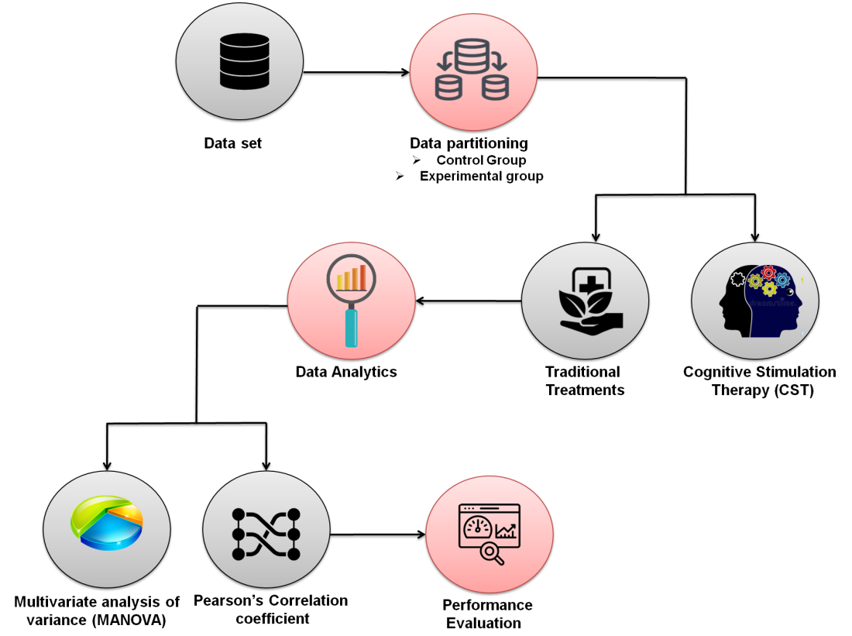
Figure 1: Working mechanism chart
A. Sample collection of data
For 8 weeks, 91 Alzheimer's individuals diagnosed in healthcare facilities or the broader population received CST group treatment numerous times weekly; the remaining 70 Alzheimer's patients underwent therapeutic interventions. A discussion with the director was scheduled after 169 potential social care and daycare facilities were approached. For inclusion, centers needed at least 8 target respondents. Due to their inability to provide enough respondents, several centers were disqualified (Knapp et al. (19)). Table 1 depicts the characteristics of patients with Alzheimer's disease.

Table 1: Fundamental characteristics of Alzheimer's disease patients
Patient's characteristics | CST & carer training | Control group | t-test
Average age (years) | 75.4 (5.51) | 76.8 (6.55) | 76.8(7.47)
Gender
Gents (%) | 11 (52.4) | 15 (62.5) | 9 (41.5)
Ladies (%) | 10 (45.6) | 9 (35.4) | 13 (55.4)
State of residence
Personalized lodging (%) | 20 (95.1) | 20 (81.1) | 23 (98)
Assisted living (%) | 0 (0) | 01 (4.1) | 0 (0)
Live-in assistance (%) | 1 (4.8) | 2 (12.5) | 0 (0)
Category of Alzheimer's diagnoses
Alzheimer’s disease (early onset) (%) | 0 (0) | 0 (0) | 1 (3.2)
Alzheimer’s disease (late onset) (%) | 18 (71.4) | 11 (46.5) | 10 (41.4)
Alzheimer’s disease (atypical/mixed) (%) | 1 (4.8) | 2 (7.5) | 5 (25.1)
Cerebral disease (%) | 0 (0) | 3 (13) | 1 (3.2)
Alzheimer's disease sub-cortical (%) | 2 (9.5) | 1 (3.2) | 2 (7.5)
Parkinson's disease-related dementia (%) | 0 (0) | 4 (15.4) | 1 (3.3)
Unknown dementia (%) | 3 (14.3) | 2 (7.6) | 1 (7.6)
Degree of dementia
Weak (%) | 15 (70.2) | 17 (73.0) | 16 (25.1)
Strong (%) | 6 (25.6) | 5 (24.0) | 5 (25.1)
Surviving with a caregiver
Yes (%) | 18 (84.6) | 15 (73.1) | 18 (81.5)
No (%) | 3 (14.2) | 4 (18.8) | 3 (15.3)
Relation to the caregiver
Spouse (%) | 15 (80.0) | 16 (68.8) | 15 (71.8)
Partner (%) | 0 (0) | 0 (0) | 1 (3.3)
Parents (%) | 3 (15.0) | 4 (18.5) | 3 (15.4)

B. Partitioning of data
A record of the respondents at the center was created by the investigator performing the evaluations. The evaluator subsequently put them in the correct order, gave each one a number ranging from 1 and 10, and provided the document to the investigator leading the qualitative research at this facility. All evaluation results have the physician's identity hidden.
Experimental group
The physician then selected digits from a counters selection and wrote them on parallel discs. A name list was constructed from the first five numbers to be chosen for inclusion in the experimental group without any limits.
Control group
The other 3 to 5 individuals were assigned to the control group, who went about their regular business during the groups. 'Basic tasks' in the majority of care facilities comprised of performing nothing. Other facilities (social care and day centers) typically offered activities like cards, piano and humming performances, creative arts projects, and participation programs. Until the test was finished in the center, the evaluator was kept in the dark about this distribution. Based on the results of the research design, they calculated that 64 participants within every group would be needed to have 80% ability to recognize a distinction between the means of two positions. Using 2 different t-tests with a 0.05 significance threshold, this was predicated on the assumption that the universal platform variability was 4.0.
C. Treatments or therapy
Traditional treatment
Patients and their caregivers participated in different degrees in each of the nine-week 60-minute sessions that made up the treatment protocol. Across the course of therapy, caregivers recorded the participant's attitude and tracked the intensity and length of enjoyable experiences. Along with using behavior control techniques, they kept an eye on variations in sadness. The melancholy phase, the behavioral treatment for sadness in Alzheimer's disease, and the value of enjoyable experiences were all covered in the introduction session. The subject of the next four sessions was locating, scheduling, and enhancing enjoyable activities for the patients. During treatment, suggestions were gathered and fun games were planned with the assistance of the Joyful Event Management Agenda. Caretaker issues including despair, tension, pressure, and rage were handled starting in the sixth session. The development of a sense of community and the planning of enjoyable activities for individuals were suggested for caretakers to help with the patient's condition. The next three sessions explored methods for identifying and dealing with behavioral issues that prevented participants from enjoying themselves. This involved detecting certain behavioral issues, examining the causes and effects of these issues, and coming up with challenging techniques for improving the behaviors in question. The last session was dedicated to creating strategies for sustaining enjoyable activities and solutions after concluding the therapy's progress.
Cognitive stimulation therapy (CST)
Cognitive stimulation therapeutic options concentrated on a series of exercises demanding mental abilities and executive function. Investigators led the session for the intervention group in settings involving five to eight respondents each. The treatment took place double the week for 7 weeks, totaling 14 appointments. Every session started with a collaborative song, then a warm-up workout, and then the primary sector focused on the week's subject. Programs were created to be as comprehensive as feasible and were adapted to the team's ability. The two additional sessions were conducted on the same day, split by a brief break, to encourage participation and lower commuting expenses and hurdles. Each session lasted around 45 minutes. Hence we analyze the patients on cognitive stimulation therapy with Alzheimer's disease based on expert consultation and semi-structured interviews.
D. Data Analytics
Analysis of data is the act of taking actual data and turning everything into documentation that people can utilize to make decisions. Data analysis is designed in a range of corporate, scientific, medical, and sociology sectors. It has many dimensions and methods and encompasses several methodologies through many designations. Analysis of the data contributes to much more logical decision-making and thus more efficient corporate operations in the competitive global economy. Inspection, purging, transformation, and modeling of data are all steps in the data analysis process, which is utilized to collect accurate data, validate inferences, and uncover patterns.
Multivariate analysis of variance (MANOVA)
The purpose of multivariate analysis of variance (MANOVA) is to examine the interaction between many layers of independent factors and predictor variables. The variables must adhere to normative specifications to use MANOVA in therapies. In similar situations as ANOVA, MANOVA is employed when there are numerous random and dependent factors in the model that the participants are asked to assess. Whenever homogeneity is breached, MANOVA is also regarded as a respectable substitute for the factorial design ANOVA. Equation (1) depicts the general form of MANOVA. MANOVA in matrix form is represented in equation (2)
$Z=XB+E$ (1)
$Z=\left[\begin{matrix}Y_{1,1} & Y_{1,2} & … & Y_{1,m} \\ Y_{2,1} & Y_{2,2} & … & Y_{2,m} \\ ⋮ & ⋮ & ⋱ & ⋮ \\ Y_{n,1} & Y_{n,2} & … & Y_{n,m}\end{matrix}\right]=\left[Y_{1} Y_{2 }… Y_{m}\right]=\left[\begin{matrix}y_{1}^{T} \\ ⋮ \\ y_{n}^{T}\end{matrix}\right]$ (2)
The n x d matrix X may not always be of complete rank d. It is depicted in equation (3)
$X=\left[\begin{matrix}x_{1,1} & x_{1,2} & ⋯ & x_{1,d} \\ x_{2,1} & x_{2,2} & … & x_{2,d} \\ ⋮ & ⋮ & ⋱ & ⋮ \\ x_{n,1} & x_{n,2} & … & x_{n,d}\end{matrix}\right]=\left[v_{1} v_{2}… v_{d}\right]=\left[\begin{matrix}x_{1}^{T} \\ ⋮ \\ x_{n}^{T}\end{matrix}\right]$ (3)
B in equation 1 is indicated in equation (4) and E in (1) is depicted in equation (5)
$B=\left[\begin{matrix}β_{1,1} & β_{1,2} & … & β_{1,m} \\ β_{2,1} & β_{2,2} & … & β_{2,m} \\ ⋮ & ⋮ & ⋱ & ⋮ \\ β_{d,1} & β_{d,2} & … & β_{d,m}\end{matrix}\right]=\left[β_{1}β_{2}…β_{m}\right]$ (4)
$E=\left[\begin{matrix}∈_{1,1} & ∈_{1,2} & … & ∈_{1,m} \\ ∈_{2,1} & ∈_{2,2} & … & ∈_{2,m} \\ ⋮ & ⋮ & ⋱ & ⋮ \\ ∈_{n,1} & ∈_{n,2} & … & ∈_{n,m}\end{matrix}\right]= \left[e_{1}e_{2}…e_{m}\right]=\left[\begin{matrix}ϵ_{1}^{T} \\ ⋮ \\ ϵ_{n}^{T}\end{matrix}\right]$ (5)
The interconnections and related significance levels of the predictor variable have an impact on the efficacy of MANOVA.
Pearson correlation coefficient
The linear correlation of two types of data is measured by the Pearson correlation coefficient. It is effectively a balanced evaluation of the covariance since the proportion seen between the covariance of two parameters and the products of its standard deviation must be between -1 and 1. Equation (6) is used to determine the Pearson correlation coefficient.
$ρ_{x,y}=\frac{cov\left(X,Y\right)}{σ_{X}σ_{Y}}$ (6)
Whenever used in a community, the Greek symbol $ρ$ (rho) is usually used to denote Pearson's correlation coefficient, also known as the community correlation analysis or the population Pearson correlation coefficient. The covariance in equation (6) is denoted in equation (7). $μ_{x }$and $μ_{y}$are found by using (8) and (9).
$cov\left(X,Y\right)=E\left[\left(X−μ_{x}\right)\left(Y−μ_{y}\right)\right]$ (7)
$μ_{x}=E\left[X\right]$ (8)
$μ_{y}=E\left[Y\right]$ (9)
$σ_{X}^{2}=E\left[{\left(X−E\left[X\right]\right)}^{2}\right]=E\left[X^{2}\right]−{\left(E\left[X\right]\right)}^{2}$ (10)
$σ_{Y}^{2}=E\left[{\left(Y−E\left[Y\right]\right)}^{2}\right]=E\left[Y^{2}\right]−{\left(E\left[Y\right]\right)}^{2}$ (11)
$E\left[\left(X−μ_{x}\right)\left(Y−μ_{Y}\right)\right]=E\left[\left(X−E\left[X\right]\right)\left(Y−E\left[Y\right]\right)\right]=E\left[XY\right]−E\left[X\right]E\left[Y\right]$ (12)
Equations (10), (11), and (12) are the variables of the above equations.
Hence the Pearson correlation coefficient is also written as in equation (13)
$ρX,Y=\frac{E\left[XY\right]− E\left[X\right]E\left[Y\right]}{\sqrt{E\left[X^{2}\right]}−{\left(E\left[X\right]\right)}^{2}\sqrt{E\left[Y^{2}\right]}−{\left(E\left[Y\right]\right)}^{2}}$ (13)
If either $σ_{X}$ and $σ_{Y}$ are 0, infinity, or indeterminate, Pearson's correlation coefficient does not exist.

IV. PERFORMANCE EVALUATION
The availability of services for healthcare is frequently utilized as a justification for not introducing innovative therapies to meet the requirements of persons with Alzheimer's disease. Medical resources are often usually limited in comparison to demands or wishes. In reality, when the advantages of improved medical conditions and life quality are significant, there may be sound economic and social grounds for expansion in Alzheimer's disease. Therefore, this research explored the application efficacy of a CST service developed in care facilities and day centers. In our study, we analyze the group result, pre-test, post-test, and results of the CST with Alzheimer's disease.
A. Group test
Initially, the control group and experimental group are investigated. Figure 2 depicts the results of the groups. In the control group, the traditional treatment is available while in the experimental group the CST with Alzheimer's disease is discussed. Compare to the control group, the experimental group has a better diagnosis of this disease within a limited time. The control group has % of CST with Alzheimer's disease diagnosis and the experimental group has % of CST with Alzheimer's disease diagnosis. It denotes that the CST with Alzheimer's disease diagnosis is very effective in practice.
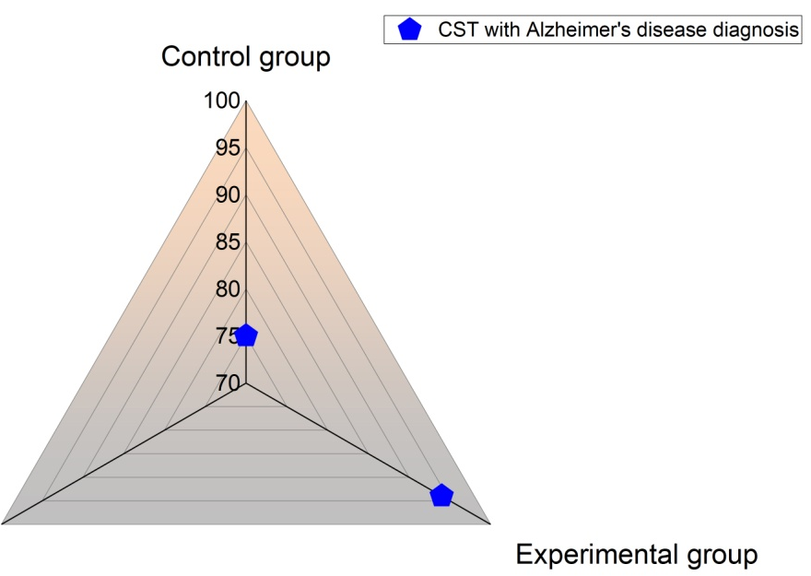
Figure 2: Results of CST diagnosis in groups
B. Pre-test result
The pre-test is conducted and analyzed the patient's health by CST with Alzheimer's disease. Figure3 represents the results of the pre-test. This therapy is conducted through sessions. Hence, a pre-test is conducted with a number of sessions and the growth of the disease. From the analysis, it is clear that the pre-test is comparatively worst because when no. of sessions increased during this test the disease growth also raised there is no impact on attending the sessions.
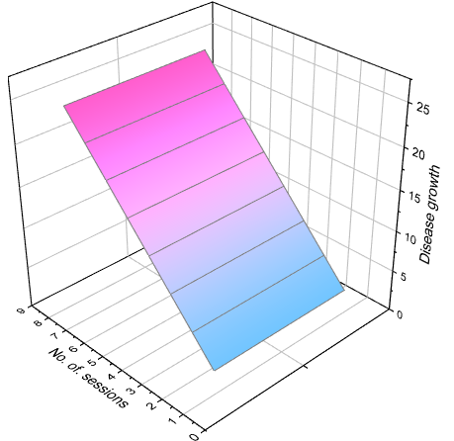
Figure 3: Pre-test
C. Post-test result
Further, the post-test is conducted and the results are gathered. Figure 4 indicated the post-test results. After the CST treatment, the patient's health is improved gradually. Here, also we compared the number of sessions and disease growth. Whenever the patients attend the sessions the growth of the disease is decreased eventually because CST treatment is well effective for the patient's health.
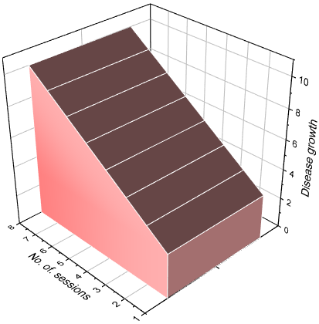
Figure 4: Post-test
D. Patient's health status
Health status is predicted before and after undergoing treatment. We already have seen the results of before treatment. Through the analysis, we predict the patient's health status after treatment. Figure 5 displays the health status of patients after taking CST. After taking CST treatment, each patient's memory, perception, attention, coordination, and reasoning are analyzed. From the figure, it is noted that the patient's health status is improved well.
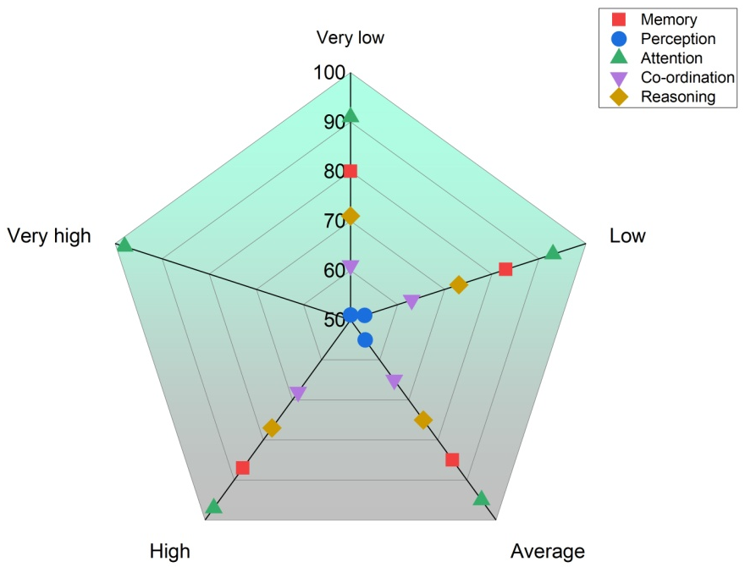
Figure 5: Patient's health level after treatment
V. CONCLUSION
In conclusion, patients who received cognitive stimulation therapy improved more in the areas of application and decreased in the areas of lethargy and sadness than would people getting primary health care. Based on expert consultation and semi-structured interviews, this study involves cognitive stimulation therapy as a therapeutic choice for people with strong to severe Alzheimer's disease diagnoses. Although it could be less costly to offer CST by teaching nurses, caregivers, or employees of care facilities, we are unsure whether the results would vary. Our findings indicate that the utilization of cognitive stimulation therapy may need to be expanded to preserve a patient's identity, mental health, and resilience in the event of cognitive loss.
REFERENCES
- Saragih, I.D., Tonapa, S.I., Saragih, I.S. and Lee, B.O., 2022. Effects of Cognitive Stimulation Therapy for People with Dementia: A Systematic Review and Meta-Analysis of Randomized Controlled Studies: Cognitive stimulation therapy for dementia care. International Journal of Nursing Studies, p.104181.
- Lauritzen, J., Nielsen, L.M., Kvande, M.E., Brammer Damsgaard, J. and Gregersen, R., 2022. Carers’ experience of everyday life impacted by people with dementia who attended a cognitive stimulation therapy (CST) group intervention: a qualitative systematic review. Aging & Mental Health, pp.1-7.
- Mody, R. N., and A. R. Bhoosreddy. &quot; Multiple odontogenic keratocyst: a case report. Annals of Dentistry 54.1-2 (1995): 41-43.
- Knapp, M., Bauer, A., Wittenberg, R., Comas‐Herrera, A., Cyhlarova, E., Hu, B., Jagger, C., Kingston, A., Patel, A., Spector, A. and Wessel, A., 2022. What are the current and projected future cost and health‐related quality of life implications of scaling up cognitive stimulation therapy? International Journal of Geriatric Psychiatry, 37(1).
- Ali, A., Brown, E., Tsang, W., Spector, A., Aguirre, E., Hoare, S., and Hassiotis, A., 2022. Individual cognitive stimulation therapy (iCST) for people with intellectual disability and dementia: Feasibility randomized controlled trial. Aging & Mental Health, 26(4), pp.698-708.
- Garg, Harita; Digital Twin Technology: Revolutionary to improve personalized healthcare; Science Progress and Research (SPR) 1.1 (2020)
- Gonzalez-Moreno, J., Satorres, E., Soria-Urios, G. and Meléndez, J.C., 2022. Cognitive Stimulation in Moderate Alzheimer’s Disease. Journal of Applied Gerontology, p.07334648221089283.
- Skov, S.S., Nielsen, M.B.D., Krølner, R.F., Øksnebjerg, L. and Rønbøl Lauridsen, S.M., 2022. A multicomponent psychosocial intervention among people with early-stage dementia involving physical exercise, cognitive stimulation therapy, psychoeducation, and counseling: Results from a mixed-methods study. Dementia, 21(1), pp.316-334.
- Andrade, S.M., da Silva Machado, D.G., da Silva-Sauerc, L., Regis, C.T., Mendes, C.K.T.T., de Araújo, J.S.S., de Araújo, K.D.T., Costa, L.P., Queiroz, M.E.B.S., Leitão, M.M. and Fernández-Calvo, B., 2022. Effects of multisite anodal transcranial direct current stimulation combined with cognitive stimulation in patients with Alzheimer's disease and its neurophysiological correlates: A double-blind randomized clinical trial. Neurophysiologie Clinique, 52(2), pp.117-127.
- Ahmed,Bilal, and Aatiqa Ali. Usage of Traditional Chinese Medicine, Western Medicine and Integrated Chinese-Western Medicine for the Treatment of Allergic Rhinitis; Official Journal of the Zhende Research Group 1.1 (2020): 1-9.
- Marinho, V., Bertrand, E., Naylor, R., Bomilcar, I., Laks, J., Spector, A. and Mograbi, D.C., 2021. Cognitive stimulation therapy for people with dementia in Brazil (CST‐Brasil): Results from a single-blind randomized controlled trial. International Journal of Geriatric Psychiatry, 36(2), pp.286-293.
- Rai, H.K., Schneider, J. and Orrell, M., 2021. An Individual Cognitive Stimulation Therapy App for people with dementia and their carers: protocol for a feasibility randomized controlled trial. JMIR Research Protocols, 10(4), p.e24628.
- Shahabaz,A., and M. Afzal. Implementation of High Dose Rate Brachytherapy in Cancer Treatment, SPR, 2021, Volume 1, issue, 3, Page No.: 77-106; DOI: https://doi.Org/10 52152.
- Carbone, E., Gardini, S., Pastore, M., Piras, F., Vincenzi, M. and Borella, E., 2021. Cognitive Stimulation Therapy for Older Adults With Mild-to-Moderate Dementia in Italy: Effects on Cognitive Functioning, and Emotional and Neuropsychiatric Symptoms. The Journals of Gerontology: Series B, 76(9), pp.1700-1710.
- Li Zihan. Treatment and Technology of Domestic Sewage for Improvement of Rural Environment in China-Jiangsu: A Research. (2022).
- Alvares-Pereira, G., Silva-Nunes, M.V. and Spector, A., 2021. Validation of the cognitive stimulation therapy (CST) program for people with dementia in Portugal. Aging & Mental Health, 25(6), pp.1019-1028.
- Salihu, S. O., and ZayyanuIyya. Assessment of Physicochemical parameters and Organochlorine pesticide residues in selected vegetable farmlands soil in Zamfara State, Nigeria.Science Progress and Research (SPR) 2.2 (2022)
- Werheid, K., Schaubs, B., Aguirre, E. and Spector, A., 2021. Cognitive stimulation therapy: Model-based cultural adaptation and manual translation of evidence-based psychosocial group therapy for people with dementia. GeroPsych: The Journal of Gerontopsychology and Geriatric Psychiatry, 34(3), p.117.
- Knapp, M., Thorgrimsen, L., Patel, A., Spector, A., Hallam, A., Woods, B. and Orrell, M., 2006. Cognitive stimulation therapy for people with dementia: a cost-effectiveness analysis. The British Journal of Psychiatry, 188(6), pp.574-580.

