Outcomes of Symptomatic Gallstone Disease in Pregnant Women:
A Retrospective Study

Awni Ismail Sultan*¹, Raakad Kamel Saadi², Mohammed Mohammud Habash³, Ozdan Akram Ghareeb⁴
¹Department of Surgery, College of Medicine, Tikrit University, Iraq
²Department of Gynaecology and Obstetrics, College of medicine, University of Diyala, Iraq
³Department of Surgery, College of medicine, University of Diyala, Iraq
⁴Department of Community Health, Northern Technical University, Iraq
*Corresponding author: Awni Ismail Sultan, Department of Surgery, College of Medicine, Tikrit University, Iraq. Email : awnisultan@tu.edu.iq

Abstract
Gallstone disease with advanced symptoms is one of the common abdominal emergencies during pregnancy, and it is considered one of the most frequently reported non-obstetric surgical conditions in pregnant women. This study aimed to evaluate the outcomes of surgical cholecystectomy in pregnant women with symptoms of advanced gallstones. A retrospective analysis of 2814 pregnant women attended various wards in governmental and private hospitals in the governorates of Diyala and Kirkuk in Iraq for more than two years, between February 2020 and June 2022. The hospital database was used to confirm the diagnosis of advanced gallstone symptoms in these pregnant women. The incidence of symptomatic gallstones in pregnant women, diagnosis and method of therapeutic management, cholecystectomy according to pregnancy periods and perinatal complications for patients according to therapeutic methods were determined. The results confirmed that out of 2814 pregnancies, only 126 (4%) had symptoms of gallstones. It was found that the majority of cases 67 (53%) were within the first trimester of pregnancy, and the least 29 (23%) in the second trimester. Acute cholecystitis was the generality 84 (67%) diagnosed in pregnant with symptomatic gallbladder disease. only 9 (7%) of pregnant patients had undergone prenatal cholecystectomy versus 117 (93%) were managed conservatively. 20 (16%) cases with undesirable complications were recorded, where 12 cases of low birth weight were noted, 4 of them underwent surgery versus 8 treated conservatively. It was concluded that a large proportion of women suffer from symptoms of gallstones during pregnancy. Most cases can be managed conservatively, and intervention should be performed as often as needed.
Keywords: Pregnancy periods, cholecystectomy, gallstones symptoms.

Introduction
Gallstone disease with advanced symptoms is one of the most common medical emergencies for the abdomen during pregnancy, along with acute appendicitis [1,2]. The incidence of diseases associated with gallstones that pose a risk to pregnancy may reach more than 7%, so managing these diseases is considered a diagnostic and therapeutic challenge for specialized surgeons [3,4]. It is known that alterations in anatomical features associated with pregnancy can make diagnosis difficult in acute abdominal emergencies [5]. Delay in diagnosis may increase the risk of perforation, and thus generalized peritonitis or sepsis, leading to premature delivery, fetal loss and maternal mortality in some cases. In contrast, early diagnosis and timely surgical intervention have been shown to give much better results in the perinatal period [6]. In recent years, there have been developments in the management of gallstone disease, although there are still concerns about the risks to the fetus as well as pregnant women [7].An accepted indication for cholecystectomy during pregnancy is symptomatic gallstone disease with failure of conservative antibiotic management [8]. It has been confirmed that laparoscopic surgeries are secured throughout pregnancy. Besides, several recent articles have suggested that surgical intervention to manage gallbladder disease, especially in the third trimester of pregnancy, may lead to higher preterm birth rates than conservative treatments [9]. However, exposing any pregnant woman to riskiness of a surgical procedure is a hard decision that the surgeon must carefully decide with the patient [10]. It should be noted that many practical researches in the past decades have been conducted in order to evaluate feasibility and safety of cholecystectomy in pregnant patients, as most of the authors encouraged surgeons to have a lower threshold for surgical intervention [11, 12]. In spite of registered safety of surgery in urgent critical cases, the outcomes of delayed surgical intervention in semi-urgent conditions are rarely documented for women with symptomatic gallbladder disease during pregnancy [13]. On the other hand, many suppose that the criterion of conservative care should be the most appropriate, with surgical mediation postponed until the postpartum period [14]. On the contrary, others believe that avoiding surgical intervention and maintaining on conservative handling can have negative effects on pregnant patient or the fetus [15]. Because there are few clinical studies that have been conducted to assess the safety and outcomes of surgery during pregnancy, we carried out this retrospective study on pregnant women with symptomatic gallstones to evaluate the outcome of surgical management.
Materials and Methods
Patients and study design
This retrospective study analyzed 2814 pregnant women attended various wards of hospitals in two Iraqi governorates, Diyala and Kirkuk, for checkup with the necessary follow-up, during a period of more than two years between February 2020 and June 2022. This study was completed after obtaining the approval of the Ethics Committee of the Kirkuk and Diyala Health Directorates. The incidence of advanced gallstone symptoms was determined based on the hospitals database to confirm the diagnosis of these pregnant women. The study included all pregnant women with completed data and diagnosed by specialized physicians, and pregnant women without it were excluded. Outcomes evaluated for patients with advanced gallstone symptoms included the following: diagnosis and management method (conservative/surgical), cholecystectomy by gestational age, and perinatal complications according to management method.

Surgical procedures
All pregnant women with symptomatic advanced gallstones were admitted for conservative management, while surgery was planned for pregnant women in the second trimester who did not respond to medical treatment. For women during the first or third trimesters of pregnancy, we continued nonsurgical treatments until surgery became feasible for unresponsive cases as they approached the second trimester or postpartum period, respectively. Conservative management included intravenous fluid administration, broad-spectrum antibiotics (third generation cephalosporins and metronidazole if no contraindications) and paracetamol injections as needed. However, when these measures failed to relieve the symptoms, the patient was prepared for cholecystectomy during pregnancy. Operatively (Figure 1), the steps are the same which are done in cases of non-pregnant ones. They were generally anaesthetized, and a single dose of preoperative antibiotic was administered, the site of the initial access port was adjusted according to the gravid uterus level, then the Veress needle was inserted with observing and holding the CO2 insufflation pressure to no more than 12 mmHg, and the other three ports were also inserted in their standard positions. Then keep on the same operative procedure as usual [16], and most cases are discharged home on next day. In cases where we encountered operative difficulties, we convert to the open approach of cholecystectomy through the right subcostal incision, and conversional open cholecystectomy was indicated for only two patients.
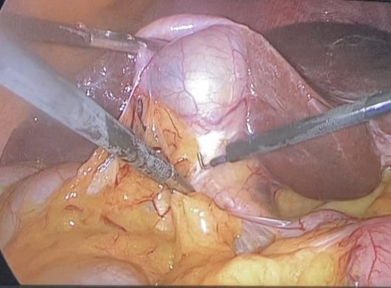 | 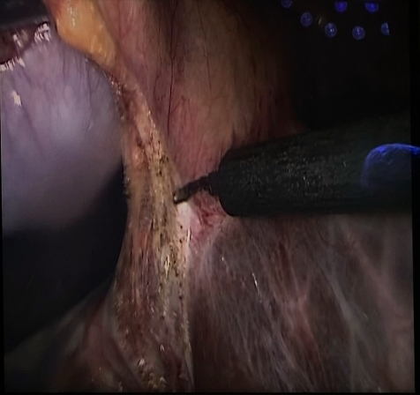 | 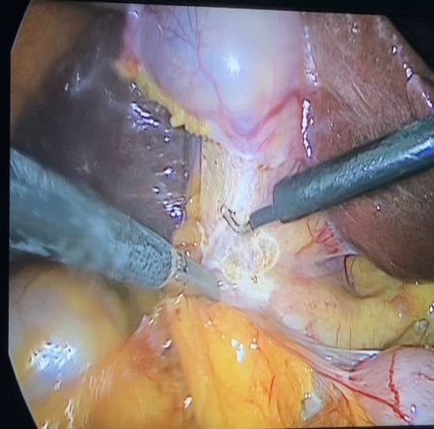
Figure 1: Cholecystectomy in pregnant women participating in the study.
Data analysis
Using SPSS program (version 26, IBM Corp), the results in this study were descriptively analyzed and tabulated. Besides using Microsoft Excel to display the results in a clear bar chart format. Data were represented as standard deviation and mean, numerical frequencies, and percentages (%), as appropriate.

Results
Of the 2814 pregnancies enrolled in this study, only 126 (4%) of them had developed gallstone symptoms (Fig. 1).
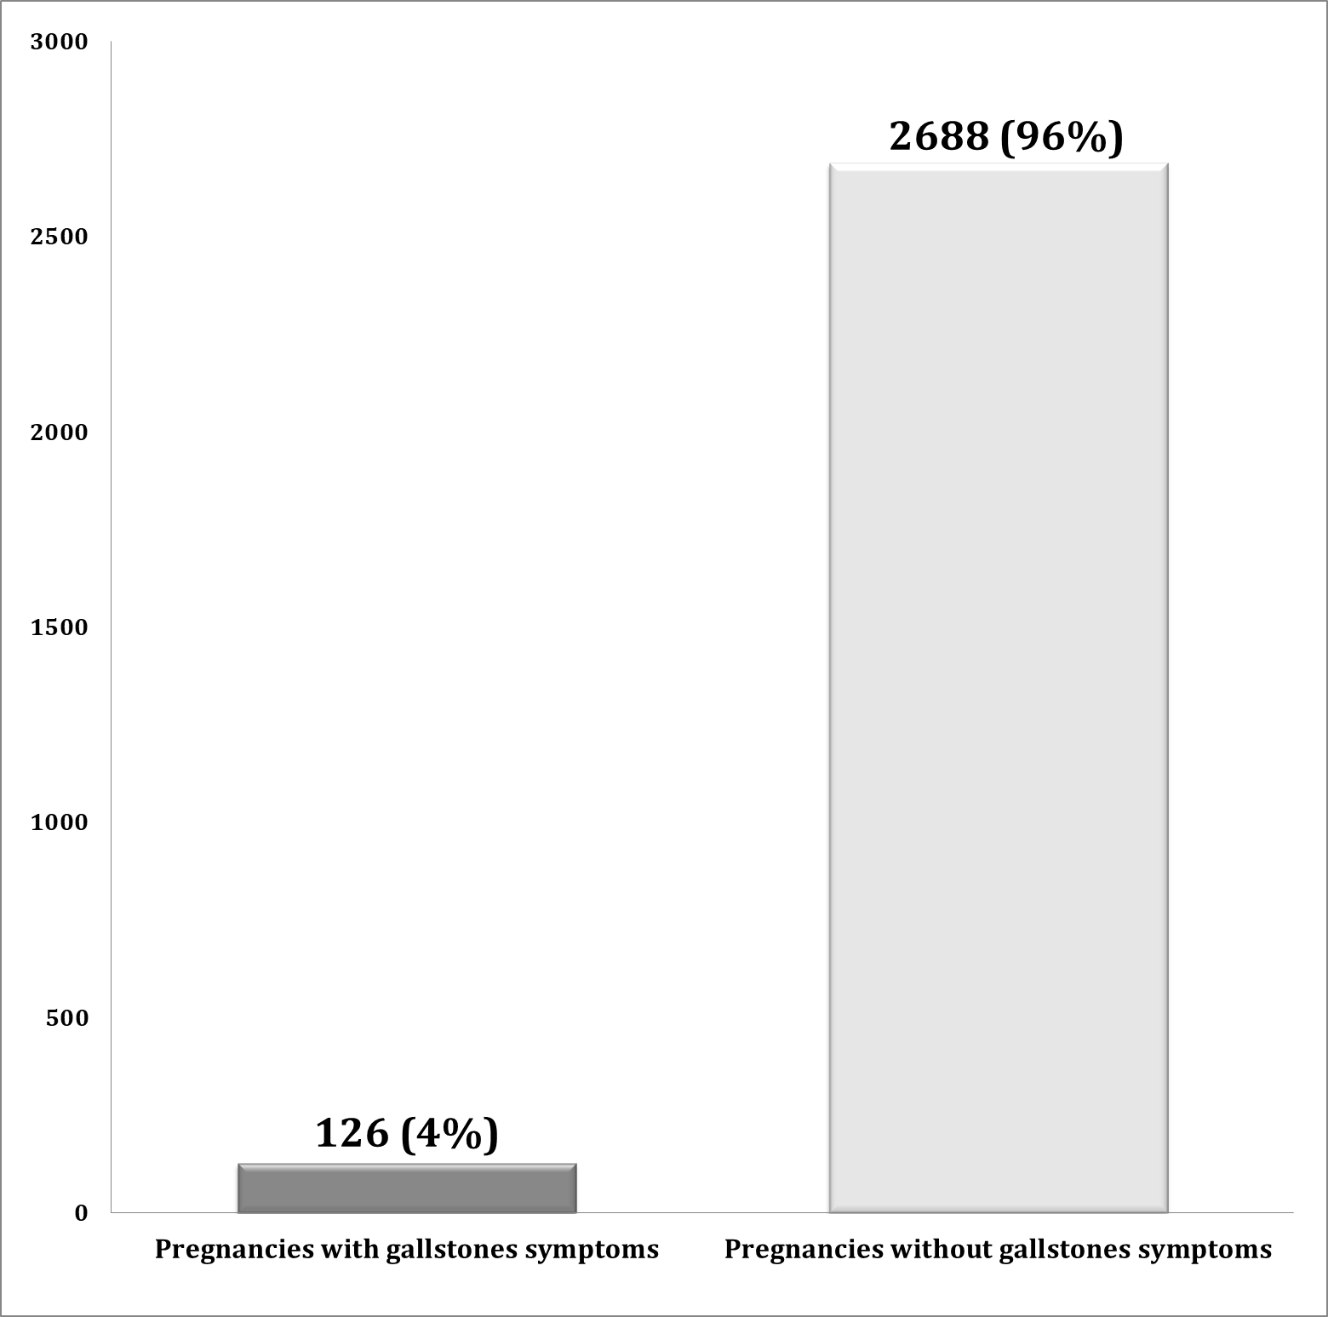
Figure 1: The incidence of gallstone symptoms for all pregnancies in the study.
Most of the pregnant with gallstone symptoms 67 (53%) were in the first trimester period, with mean of age 30 ± 3, followed by 30 (24%) patients in the third trimester, and the remaining 29 (23%) patients in the second trimester (Table 1).

Trimester | Frequency (%) | Mean of Age | Parity
First | 67 (53 %) | 30±3 | 4 (1-6)
Second | 29 (23 %) | 29±5 | 2 (1-4)
Third | 30 (24 %) | 31±4 | 3 (1-5)
Total | 126 (100 %) | 30±4 | 3 (1-6)
Table 1: Baseline characteristics of patients throughout pregnancy

Results confirmed that acute cholecystitis was the most common case of complicated gallstones diagnosed during pregnancy 84 (67%), followed by acute pancreatitis 23 (18%) cases in pregnant patients. In addition, only 9 (7%) of patients had undergone prenatal cholecystectomy and 117 (93%) were treated conservatively. Of the total cholecystectomy in 9 pregnant women, 7 patients underwent laparoscopic surgery (table 2).
Table 2: Diagnosis of patients and method of therapeutic management
Diagnosis | Frequency (%) | Therapeutic management
Diagnosis | Frequency (%) | Conservatively | Cholecystectomy
Diagnosis | Frequency (%) | Conservatively | Laparoscopic | Open
Acute cholecystitis | 84 (67%) | 80 | 4 | _
Acute cholangitis | 6 (5%) | 5 | _ | 1
Acute pancreatitis | 23 (18%) | 21 | 1 | 1
Choledocholithiasis | 13 (10%) | 11 | 2 | _
Total | 126 (100%) | 117 | 7 | 2

As shown in Table 3, only 1 (11%) patients underwent laparoscopic cholecystectomy during the first trimester, 5 (56%) patients in the second trimester, and the remaining 3 (33%) patients in the third trimester.An open resection was done in 2 patients in their third trimester due to insufficient exploration during laparoscopy.

Table 3: Cholecystectomy for patients according to the period of pregnancy
Pregnancy period | Cholecystectomy | Laparoscopic Surgery | Open Surgery
First trimester | 1 (11 %) | 1 (11 %) | _
Second trimester | 5 (56%) | 5 (56%) | _
Third trimester | 3 (33 %) | 1 (11 %) | 2 (22 %)
Total | 9 (100 %) | 7 (78 %) | 2 (22 %)

In Table 4, perinatal complications are summarized. Out of 126 patients, 20 (16 %) of them had undesirable complications, as it was noted that 12 (9 %) of the infants were suffering from low birth weight, 4 of these underwent surgery and the rest were treated conservatively. It was also observed that 6 (5%) pregnant women had preterm delivery, only 2 of whom underwent cholecystectomy surgery. On the other hand, 1 (1 %) pregnant woman had a missed abortion, and she was treated conservatively. There was one maternal death for patient suffering from acute pancreatitis with covid-19 infection.
Table 3: Complications of perinatal conditions for pregnant and infants
Complications | Frequency (%) | Therapeutic management
Complications | Frequency (%) | Conservatively | Cholecystectomy
Missed abortion | 1 (1 %) | 1 | /
Preterm delivery | 6 (5 %) | 4 | 2
Maternal mortality | 1 (1 %) | 1 | /
Low birth weight | 12 (9 %) | 8 | 4
Total | 20 (16 %) | 14 | 6

Discussion
It is known that the pregnant woman undergoes physiological changes that contribute to the formation of an ideal environment for the development of gallstones, as the high estrogen hormone increases the secretion of cholesterol, in addition to that progesterone reduces the secretion of bile acid and delays the emptying of the gallbladder, which leads to excessive saturation of bile with cholesterol and a predisposition to the formation of gallstones [17,18]. According to obtained data, among the 2814 pregnancies registered in this study, the incidence of developing gallstone symptoms was (4%). Most of those cases were in the first trimester, followed by the third trimester of pregnancy. Thus, we found the symptoms of gallstones developed in a large proportion of pregnant women. This is almost consistent with other similar studies, in a previous prospective study by Ko et al (2005) on 3254 pregnant women in a military medical center, they found gallstones developed in (5.1%) in the second trimester, and (7.9%) in the third trimester. Thus, they have proven that gallstones are common in pregnancy [19].In another prospective study by Schwulst & Son (2020) on more than 3,000 pregnant women, approximately (8%) were diagnosed with gallstones and 1.2% developed symptoms of gallstone disease [20]. The surgical approach during pregnancy remains controversial [12], this study evaluated outcomes in women with advanced gallstones during pregnancy, and compared a conservative nonsurgical approach to surgical cholecystectomy. About 117 (93%) pregnant patients were managed conservatively versus 9 (7%) underwent prenatal cholecystectomy, of which 7 patients underwent laparoscopic surgery compared to only 2 cases of conventional open surgery. Laparoscopy is a common general surgery, especially in the abdomen. Typically, most surgeons are motivated to use the laparoscopic technique because of some good considerations, including improved prognosis, significantly lower mortality rates in surgery, and lower morbidity. On the other hand, laparoscopic surgery is preferred over traditional open surgery due to the smaller incision, shorter recovery time, and the surgeon being able to better see as well as enlarge the structure of the abdominal cavity. [21,22]. Dhupar et al (2010) conducted a retrospective analysis on fifty-eight cases at a large regional obstetric referral center over a 3-year period diagnosed with symptomatic gallstones, they concluded that delaying cholecystectomy in a pregnant patient with gallbladder disease led to increased morbidity in the short and long term, and cholecystectomy during pregnancy led to a lower complication rate, noting that they were all completed by laparoscopy [23]. In another previous retrospective analytical study conducted by Hedström and colleagues (2017) to compare conservative management and surgical intervention of pregnancies with gallstone-related disease, their findings support surgical intervention in pregnancy [24] . In a similar recent Korean study conducted by Lee et al. (2022) conducted on 2941 pregnant women underwent appendectomy or cholecystectomy within ten years, they concluded that laparoscopic surgery was feasible and safe without negative results after surgery, with the need for close monitoring of premature birth after surgery, especially for patients underwent laparoscopic surgery in the first and third trimesters of pregnancy [25]. Through the results of our study, surgical management of symptomatic gallbladder disease in pregnant women has been beneficial and has contributed to the reduction of expected perinatal complications for pregnant women and infants.
Conclusions
According to the results of this study, it was concluded that a large proportions of women suffer from advanced symptoms of gallstones during pregnancy. Most cases can be managed conservatively, with intervention performed as often as needed. Our study also demonstrated that surgical management for pregnant women with symptomatic gallbladder disease was safe and reduced perinatal complications.
References
- Lightner AL, Mathis KL. Surgery in Pregnancy. Official journal of the American College of Gastroenterology| ACG. 2022 Oct 1;117(10S):53-9.
- Zachariah SK, Fenn M, Jacob K, Arthungal SA, Zachariah SA. Management of acute abdomen in pregnancy: current perspectives. International journal of women's health. 2019;11:119.
- Date RS, Kaushal M, Ramesh A. A review of the management of gallstone disease and its complications in pregnancy. The American Journal of Surgery. 2008 Oct 1;196(4):599-608.
- Rampersad FS, Chan A, Persaud S, Maharaj P, Maharaj R. Choledocholithiasis in Pregnancy: A Case Report. Cureus. 2022 Feb 25;14(2).
- Zachariah SK, Fenn M, Jacob K, Arthungal SA, Zachariah SA. Management of acute abdomen in pregnancy: current perspectives. International journal of women's health. 2019;11:119.
- Mukherjee R, Samanta S. Surgical emergencies in pregnancy in the era of modern diagnostics and treatment. Taiwanese Journal of Obstetrics and Gynecology. 2019 Mar 1;58(2):177-82.
- Brady CW. Liver disease in pregnancy: what's new. Hepatology Communications. 2020 Feb;4(2):145-56.
- Hedström J, Nilsson J, Andersson R, Andersson B. Changing management of gallstone-related disease in pregnancy–a retrospective cohort analysis. Scandinavian Journal of Gastroenterology. 2017 Sep 2;52(9):1016-21.
- Bass RB, Teitelbaum EN. Novel advances in surgery for Gallstone Disease. Current gastroenterology reports. 2022 Jul 13:1-0.
- Sedaghat N, Cao AM, Eslick GD, Cox MR. Laparoscopic versus open cholecystectomy in pregnancy: a systematic review and meta-analysis. Surgical endoscopy. 2017 Feb;31(2):673-9.
- Kamalapurkar D, Pang TC, Siriwardhane M, Hollands M, Johnston E, Pleass H, Richardson A, Lam VW. Index cholecystectomy in grade II and III acute calculous cholecystitis is feasible and safe. ANZ journal of surgery. 2015 Nov;85(11):854-9.
- Cohen SB, Watad H, Shapira M, Goldenberg M, Mashiach R. Urgent laparoscopic surgeries during the third trimester of pregnancy: a case series. Journal of minimally invasive gynecology. 2020 May 1;27(4):909-14.
- Gallo AS, Collins C. The Difficult Patient. In The SAGES Manual of Acute Care Surgery 2020 (pp. 287-308). Springer, Cham.
- Weinstein MS, Feuerwerker S, Baxter JK. Appendicitis and cholecystitis in pregnancy. Clinical Obstetrics and Gynecology. 2020 Jun 23;63(2):405-15.
- Weinstein MS, Feuerwerker S, Baxter JK. Appendicitis and cholecystitis in pregnancy. Clinical Obstetrics and Gynecology. 2020 Jun 23;63(2):405-15.
- Sultan AI, Ali SH, Ghareeb OA. Port Site Consequences After Laparoscopic Cholecystectomy Using an Open Versus Closed Approach of Pneumoperitoneum. Cureus. 2022 Jul 1;14(7).
- Littlefield A, Lenahan C. Cholelithiasis: Presentation and management. Journal of midwifery & women's health. 2019 May;64(3):289-97.
- Sethi A, Banerjee S, Chahal P. Advanced endoscopic procedures in pregnancy. Official journal of the American College of Gastroenterology| ACG. 2022 Oct 1;117(10S):39-43.
- Ko CW, Beresford SA, Schulte SJ, Matsumoto AM, Lee SP. Incidence, natural history, and risk factors for biliary sludge and stones during pregnancy. Hepatology. 2005 Feb;41(2):359-65.
- Schwulst SJ, Son M. Management of gallstone disease during pregnancy. JAMA surgery. 2020 Dec 1;155(12):1162-3.
- Habash MM, Thabet RF, Abood AM, Ghareeb OA. Comparative Study between Open and Laparoscopic Appendectomy in Acute Appendicitis. The Egyptian Journal of Hospital Medicine. 2022 Oct 1;89(2):7567-70.
- Habash M, Sultan A, Ghareeb O. Surgical Outcomes of LigaSure Bipolar Device versus Conventional Technique in Total Thyroidectomy. Journal of Natural Science, Biology and Medicine. 2022 Jan;13(2):119-23.
- Dhupar R, Smaldone GM, Hamad GG. Is there a benefit to delaying cholecystectomy for symptomatic gallbladder disease during pregnancy?. Surgical endoscopy. 2010 Jan; 24 (1) :108-12.
- Hedström J, Nilsson J, Andersson R, Andersson B. Changing management of gallstone-related disease in pregnancy–a retrospective cohort analysis. Scandinavian Journal of Gastroenterology. 2017 Sep 2;52(9):1016-21.
- Lee JH, Choi JY, Kim YJ. Safety of laparoscopic surgery during pregnancy: a Korean nationwide population-based study. Surgical Endoscopy. 2022 Mar 18:1-2.

